Cross Words
Monthly Newsletter of Cross Ev. Lutheran Church
January 2013 Volume 13, Issue 1

I Need More…TIME

Congratulations! You made it through another holiday season and into another new year! As you flip the calendar to 2013, you may reflect upon the events of the previous year—gatherings and graduations, birthdays and business, kids and careers, vacations and visits. As you do so, you may wishfully think, “If only I had a little more time. More time with my kids. More time with my elderly parents. More time to relax and enjoy life.” With a slight sense of regret and a quick glance at what may seem like a schedule fuller than ever, you may feel like throwing up your hands and shouting, “I need more time!”

Jesus said, “I have come that you may have life and have it to the full” (John 10:10). You might be thinking that your life is full enough. You do not need more things to do. You need more time! But Jesus is not talking about doing more things. Jesus is talking about a fulfilling life that has a purpose from beginning to end and into eternity.

Jesus entered our world 2000 years ago as a child whose birth we celebrated once again in December. Jesus’ purpose in life was simple. Jesus came to earth so that when our time on earth comes to an end, we can spend eternity with him in heaven. In order to make that happen, Jesus lived every moment of every day in perfect obedience to his Heavenly Father. His life temporarily ended at the cross when he suffered the punishment of sin for all people of all time. Just three days after his death, Jesus came back to life in order to proclaim his victory over death and his gift of life with God.

What a full life Jesus gives to us! We do not need to be weighed down by the guilt of our past—things we have regretfully done or left undone. Jesus came to live a perfect life in our place. We have confidence for the future because Jesus is already at the finish line, waiting to welcome us into heaven. Life is no longer about cramming as much as possible into every day. Rather, life is about living each moment of every day in gratefulness to our Savior Jesus.

Need more time? Spend time with Jesus. Get to know him through his Word. Discover the fullness of his love and purpose for you. While he may not give you the additional hour(s) you were hoping for each day, Jesus will help you to make the most of the time he gives to you.
THE VISIBLE CHURCH
A Place to Gather

I belong to a church. It’s called Good Shepherd Ev. Lutheran Church and has some 1,600 members on its roster. When I look at the pictorial directory, it’s plain to see who those members are. Other churches dot the landscape in large cities and small villages all around the world.
From God’s perspective, the church is invisible, composed only of believers in Christ. From our human perspective, the church is visible, composed of people gathered around the Word in congregations, synodical groupings, and other forms. Signs, buildings, and parking lots all identify a place where believers gather. The church is the people. Everyone can see them coming for worship and meetings.
Scripture uses the term church in this way. St. Paul wrote, “To the church of God in Corinth.” He could call them a church because he was writing “to those sanctified in Christ Jesus and called to be holy” (1 Corinthians 1:2). Because of the presence of believers, Paul could call the group at Corinth a church. The difference is the invisible church is made up of all who ARE believers in Christ. Visible churches are made up of all who SAY they are believers in him.
Sadly, hypocrites can be found in the visible church. Let’s call them make-believers, because for one reason or another they only pretend to believe in Christ. Perhaps it’s peer pressure that brings them into church membership. Others may come because of the desire for the respectability that membership seems to offer. Their names are on the congregational roster but not in God’s book of life in heaven.
How do we deal with such make-believers? We don’t! Remember, we can’t look into a person’s heart and identify faith. Nor can we look at a person’s life and identify faith from the works we see there. Even the hypocrite and the heathen can pursue good and honorable lives. Instead, we wait and let Jesus deal with the weeds in the wheat field of his church. In 1 Corinthians 4:5, Paul urges us, “Wait till the Lord comes. He will bring to light what is hidden in darkness and will expose the motives of men’s hearts.”
I can see who belongs to Good Shepherd Church. You can see who belongs to your church too. But only God can see who belongs to his church. Pray that God in his grace keeps us in that number.
© 2012 Northwestern Publishing House. All rights reserved.
Scripture is taken from THE HOLY BIBLE, NEW INTERNATIONAL VERSION.®

NEWS FROM CHURCH

NEW PIANO – The new piano in the church was purchased by the choir. Funds to purchase this piano came from memorials to the choir and proceeds from Easter Breakfasts saved up for several years. We thank those who made donations to the choir and pray that the Lord will bless its use to the praise and glory of His name!
MEMORIAL A new Bunn Dual Automatic coffee maker has been purchased for the church kitchen in memory of Robert Holslin by the Holslin family. We thank them for this gift. We also thank Shawn Lawrence and Tom Ernst for installing the coffee maker.
WINDOWS Some of you may have noticed the new windows sitting in the church basement. These are the replacement windows for the office/education wing of the church. The cost for these windows and the paint and others materials for their installation was about $8,721. Volunteers will be painting the windows before their installation. Ernst Construction will be doing the installation.
CHURCH BOILERS The trustees have recently had the boilers that provide heat for the church inspected by McDowell Company out of St Cloud. It was discovered that one of the two boilers was not functioning. They will be doing further checking to see why the boiler is not working and will also be installing a control system to help the boilers run more efficiently.
ANNUAL MEETING The Annual Congregation Meeting will be held on Sunday, January 20, 2013 at 10:15 am (following the morning worship service). In addition to reviewing the Annual Report for 2012, the election of church council officers will take place. Up for election will be the positions of congregation secretary, 2 elders and a trustee. The proposed budget for 2013 will be presented for approval. Also a proposed Church Use Policy (for weddings, etc.) will be presented for approval. All members are encouraged to attend.
CHURCH UN-DECORATING We would like to take down and put away the Christmas Tree and decorations on Saturday, January 5th, starting at 10:00 am. If you are able to help with the task, your help will be greatly appreciated.

CROSS LIGHTS Cross LIGHTS is scheduled to meet on Tuesday, January 89 at 7:30 pm. Watch the Sunday bulletin for details.
MEN’S BREAKFAST BIBLE STUDY
The January meeting of the Men’s Breakfast Bible Study will take place on Saturday, January 19 at 9:00 am. The menu will include bacon, eggs, hash browns and toast.We will continue our study – How Can They Teach That? (And Still Claim to Believe The Bible). Lesson 3 deals with women serving in the public ministry.
This is a good opportunity to review what the Bible teaches on these subjects, and how some twist or ignore what God’s Word says.
SENIOR FELLOWSHIP The Senior Fellowship will hold its first meeting of the year on Thursday, January 24, starting at noon. There will be a soup and sandwich lunch, followed by a topic or study presentation. Watch the church bulletin for more details.
WORSHIP COMMITTEE The Worship Committee will meet on Thursday, January 24 at 7:00pm. On the Agenda will be the proposed worship schedule for February through May, include the Lent and Easter schedule.
HOLY COMMUNION SCHEDULE We will return to the “regular” Communion schedule (1st & 3rd weeks of the month) starting on the 3rd week in January (January 16th & 20th)
NEW YEAR’S RESOLUTION If your New Year’s resolutions included getting more into God’s Word, your congregation offers several Bible Study opportunities to help with that.
The Sunday Morning Bible Study meets from 10:15 am to 11:15 am (during the Sunday School hour – don’t just drop the kids off for Sunday School, stay for Bible Study) in the basement fellowship hall. This is open to all members (and visitors). Currently we are working through a study called Families of the Bible, looking at various families presented in the Bible and learning lessons, both positive and negative, from them. Coffee and goodies are also served!
Monday morning’s is when our Walnut Bible Study meets (named after the meeting place – the family room of the Walnut Apartments at the west end of town). We meet 9:30 am to 10:30 am. Currently we are looking at Jesus’ ‘I AM’ Statements, based on the Gospel of John and other cross-reference passages. All who are able to make this study are welcomed to attend.
As mentioned above, once a month, usually on the 3rd Saturday of the month, the men of the congregation have the opportunity to come to the Men’s Breakfast Bible Study, as we gather for food for the body AND soul.
If you don’t already, consider coming to one or more of these studies. Watch the newsletter and bulletin for other opportunities to grow in your knowledge and understanding of the Word of God

NEWS FROM WEST LUTHERAN HIGH SCHOOL

Sign Up at West

Sign up at West

Lutheran Mobile Clinic December 2012

Kristmasiya Bwino!

I hope this letter finds you happy and healthy! I am glad to say that I am now quite healthy after a few weeks of not being so. It seems that I had a virus that was making me ill, but it has now run its’ course. I am so thankful that Maria was here to keep things running smoothly when I was unable to do much more than get out of bed.

I am writing to you from beautiful Cape Maclear, which is in Lake Malawi National Park. I am sitting under a couple of large shade trees with a view of the lake as I write to you. There is a nice breeze and the temperature is around 80 degrees Fahrenheit (if we go far from the beach the temperature rises dramatically). No snow here! It is going to be an unconventional Christmas for Maria and me this year. Since the clinic is closed for the week of Christmas we decided to do a little traveling in Malawi. We arrived here yesterday; tomorrow we will be heading to Mvuu Camp in Liwonde National Park and will be staying there until the 26th. We’ll be doing a safari on Christmas Day – that will be a first for both of us. We’ll be getting together with the other Malawi Missionaries for a Boxing Day celebration (on the day after Boxing Day).

I wish that I could tell you that we have a functioning borehole at our clinic in the village of Thunga, but we still have not been successful with that. Two weeks ago the driller made an attempt but was not able to find any water at a depth of 55 meters. For various reasons, such as equipment breakdown and hard rains causing impassible roads, we still wait. We hope that soon after the Christmas holiday they will be making another attempt. For now we continue to pray that we will have a borehole that functions all year (including the dry season) very soon.

The kwacha has continued to devalue slightly. Diesel costs about 7 dollars per gallon right now. Because the dollar is strong compared to the kwacha it is helping Lutheran Mobile Clinic, but the Malawians are feeling the fuel cost acutely. Many people are able to only partially fill their tanks because they cannot afford an entire tank of fuel. I am told that is the reason for long fuel queues that we are seeing lately. We still are occasionally unable to find diesel for a week but then the next week it is available again. The Malawi president has stated that she does not see any problem with the fuel situation, but when talking with the average Malawian, there is much frustration.

The number of patients we are seeing in our clinics is on the rise as is usual for this time of year. We are seeing lots of patients with Malaria and Upper Respiratory Infections. Epilepsy continued to be in our top five diagnoses for November and I expect it will be the same for December.

This has been a year full of blessings for LMC! We have a wonderful, caring and competent staff. We are also blessed with excellent temporary staff that fills in for our staff during illnesses or vacations. We have Pastor Mabedi who leads devotion at our Mwalaulomwe Clinic on Thursdays and competent laymen that lead devotions at our Chiwamba Area clinics. We have always managed to get enough fuel, and despite some bad roads we were always able to get to our clinic sites. We’ve enjoyed the support of our Mission Family who encourage us and lend a listening ear.

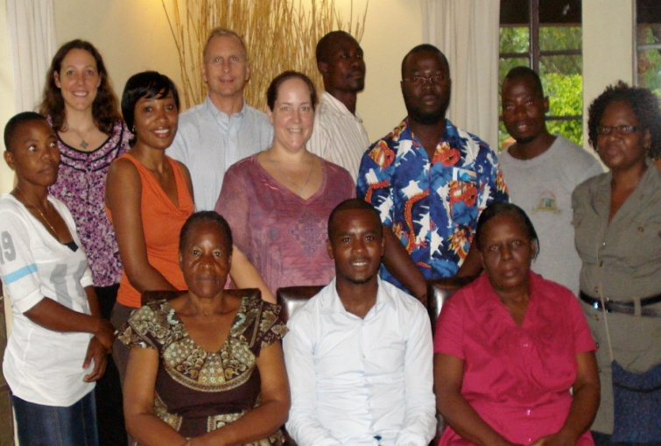

Have a Merry Christmas and a Blessed New Year!
Kari (and Maria)

“For to us a child is born, to us a son is given, and the government will be on his shoulders. And he will be called Wonderful Counselor, Mighty God, Everlasting Father, Prince of Peace.” Isaiah 9:6 (NIV)

