

Cross Words

Monthly Newsletter of Cross Ev. Lutheran Church

November 2011 Volume 11, Issue 11

**Hallelujah!**

***Give thanks to the Lord, for he is good; his love endures forever.***

***Psalm 118:1***

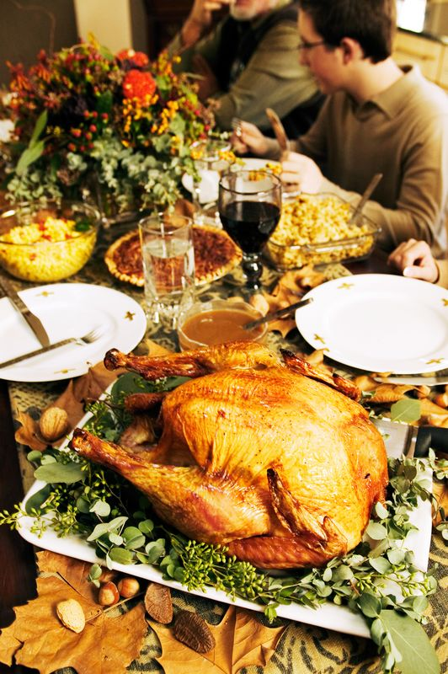

Oil flowed into the Gulf of Mexico like water over Niagara Falls. Anarchists revolted at a meeting of the world’s leaders and set police cruisers on fire. *“God is good? He has enduring love? Show me.”*

Children are born with birth defects. Convenience store clerks are shot. The economy is uncertain. Unemployment threatens the stability of millions of families. People still die. I am lonely. *“God is good? He has enduring love? Show me.”*

Has anyone, or anything, ever let you down? Plenty of times. Has your love ever gone unreturned? You’ve stopped counting. Many times you’ve probably wondered where to turn; you’ve asked, “Who can I trust?”

This psalm calls out to you, to me. It’s an “Hallelujah” psalm, meaning “Praise the LORD!” Long ago, God’s people sang the words of this psalm toward the end of their Passover meal. That special occasion was a time for the people to remember how God rescued their nation from slavery in Egypt; it was a picture of God’s rescue of all people from their slavery to sin. The Passover meal was a way that God showed each generation how much he truly loved them.

Would disaster continue to interrupt their lives? Would prosperity be withheld? Would earthly death continue to pick away at their loved ones? Yes, yes, and yes. Yet the people sang out praise and thanks to their merciful God for deliverance from all these trials of life. . . and more: “Because of his great love for us, God, who is rich in mercy, made us alive with Christ even when we were dead in transgressions—it is by grace you have been saved” (Ephesians 2:4,5).

It is the custom in North America to gather this time of year to celebrate *Thanksgiving*. Whether you are with family, friends, or celebrating alone, take the time to give thanks to our Savior God for his mercy and deliverance from death through Jesus. Jesus shows us that God is good. Jesus proves that his love for us endures forever.

**Names of Wondrous Love**

THE LAMB

*Look, the Lamb of God, who takes away the sin of the world!*

Now it rests on her dresser top, almost forgotten, fleece matted down, one ear partially torn off. But for many evenings it had been on her pillow, nestled next to her cheek as her “security” lamb. How different with the Lamb to whom John pointed that day along the Jordan!

For centuries God’s people had been waiting for that Lamb. They had plenty of reminders that he was coming. Every day two lambs were offered in their temple and at times even more as special sacrifices. The blood of all those lambs couldn’t erase a single one of the people’s sins. But it did point to the Lamb who could. Now he had come, and John had the privilege of announcing for all to hear, “Look, the Lamb of God, who takes away the sin of the world!” (John 1:29).

This is not some lamb that I want close to me for a day or two. He’s not some security symbol that has no real power. He is God’s own eternal Son sent from heaven by wondrous love. God sent him to take on my skin, to take on my sins, to take them to Calvary’s cross, there to take them away forever. John was right! I need to look at that Lamb of God. I can’t afford not to because of my sins. And when God fastens my eyes of faith on that Lamb, I have all the security I need. By God’s grace, I know all about pardon for my sins, peace with my Father, and the promise of his heaven as my eternal home.

I can’t help noticing though, how John pointed out that Jesus is more than just my Lamb. He clearly stated that God sent his Lamb, “who takes away the sin of the world.” Not just Israel’s sins, not just John the Baptist’s sins, not just my sins, not just your sins, but the sins of the world were laid on and paid for by this divine Lamb. Do I hear what John’s telling me? I can’t just hold that precious Lamb of God close to my heart. He didn’t come just to bring me eternal security. I need to be vitally concerned about taking the Lamb of God to others. They need him too, just as much as I do.

What a name, the Lamb, my Savior-God has! It shines brightly with his wondrous love.

© 2011 Northwestern Publishing House. All rights reserved.

Scripture is taken from THE HOLY BIBLE, NEW INTERNATIONAL VERSION.®

**BIBLE STUDY OPPORTUNITIES AT CROSS**

**Sunday Morning Bible Study**

The Sunday morning Bible Study is at 10:15 am. (during the family Bible Hour) We are studying of the book of Esther, using the Scripttures, along with a full-length movie of the same name, featuring the ever-popular Louise Lomabrd and F. Murray Abraham. As always, coffe and freshments willl be served. Make your plans to be there.

**Walnut Bible Study**

Monday mornings, at 9:30 am Walnut Bible Study is held at the Walnut Apartments in the family room. Everyone in the congregation is invited to join us. We will be starting a study of Paul’s letter to the Ephesians, a study in God’s grace

**Teen Bible Study**

The Teen Bible Study will also take place on Sundays during the Family Bible Hour in the YUC Longe. This study gtives kids in High School an opportuinity to continue to grow in the knowledge of God’s Word, and how it applies to their lives. We will start with a study called: *Prodigal Perspectives: A Parable About Selfishness, Jealousy & Forgiveness.* This is a study based on Jesus’ parable of the Lost Son. It will be a good study.

This time together on Sunday mornings will be time to touch base on planning other youth and YUC events and activities. So kids, you don’t have anything else to do on Sundays right after church – so be there!!!

**Men’s Breakfast Bible Study**

The Men’s Breakfast Bible Study will continue it study on *Spiritual Leadership.* This study will look at the great opportunity and priviledge God gives us to be spiritual leaders in our families and how this impacts our social and church lives.

***We will meet on Saturday, November 19 at 9:00 am this month. French Toast will be on the menu, in addition to God’s Word. There will be a special guest presenter, the author of the booklet we are following, Pastor David Russow, who serves the Lord at Redeemer Grace Lutheran Church in Rogers, MN. Men of the congregation, this is a great chance for spiritual growth!!***

***sign-up sheet is posted in the entryway for the members of Cross to sign up and indicate what they plan to bring.***

In addition to food and fellowship, we will have a “Thanksgiving & Christmas Hymn Sing”, learning the background and history of some of our favorite Thanksgiving and Christmas hymns, as well as joining in singing a few verses of each.

This is always an enjoyable event. We encourage all who can come to attend and invite a friend or two!!!

**THANKSGIVING WORSHIP**

Our Thanksgiving Worship services will be on *Wednesday, Nov 22 at 7:00 pm and Thursday, Nov. 23 at 9:00 am.* Take the time ***to give*** ***thanks to the Lord, for he is good; for his steadfast love endures forever!*** Psalms 118:1 (ESV)

**SUNDAY SCHOOL CHRISTMAS PRACTICE**

The Sunday School will begin their preparation for the Children’s Christmas service on Saturday, November 25 at 10:00 am. The 3 remain practices on the following Saturdays will also start at 10:00 am. Parents, plan to have your children take part in this service, get them to practice on time and help them learn their Christmas hymns and recitations.

The theme of this year’s “Children’s Christmas service will be ***We Sing of His Glory.*** It will take place on Sunday, December 18 at 9:00 am. This service, in a sense, kicks off Christmas Week at Cross, with Christmas Eve and Christmas Day the following Saturday and Sunday. This service is an excellent opportunity to prolong the celebration of the Savior’s birth.

**The Annual**

**“HANGING OF THE GREENS”**

We will put up the Christmas tree and decorations in and around the church on Sunday, Dec 4 – our annual *Hanging Of The Greens.*  The festivities will start with a pot luck dinner at noon. After dinner, we will get to work with smiles on our faces and Christmas songs in our hearts! ***All the members of the congregation are invited and encouraged to come at take part. Even if you can’t climb on a ladder or do much else, we can always use supervisors***

C:\Users\church office\AppData\Local\Microsoft\Windows\Temporary Internet Files\Content.IE5\W2ARXDUE\MC900232598[1].wmf

***.***

[](http://r20.rs6.net/tn.jsp?llr=ufmcuvn6&et=1107909389475&s=431545&e=001cNURP20M8FFgmYKOahXQBD2DCCozoscqh_an9FKOPcI9AmGwv2YmUvMyKT7y6seRnEdriG5nossxA6IEOif3-v-p8pRHqsN63W1LUR1mZxSx4_TQ3ByheA==)

**CHRISTMAS for KIDS**

On Saturday, December 10, the Evangelism Committee will be hosting our annual *Christmas For Kid,* from 12:00 pm to 3:30 pm. There will be food, games, crafts and a showing of the Veggie Tales movie, *The Little Drummer Boy.* All the children of our congregation preschool through 5th grade are invited. This is also a time to invited the children of relatives and friends, especially those without a church home. A sign-up sheet will be posted.

**WEST LUTHERAN HIGH SCHOOL**

**Fall Play  
A Play in Two Acts Adapted by Anne Coulter Martens**

[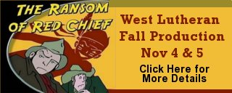](http://www.wlhs.net/site/cpage.asp?cpage_id=180009133&sec_id=180003621)

**Evening shows open to the public:**  
Nov 4 & 5, 7 PM, doors open at 6:30  
  
A free-will offering will be collected to off-set expenses.